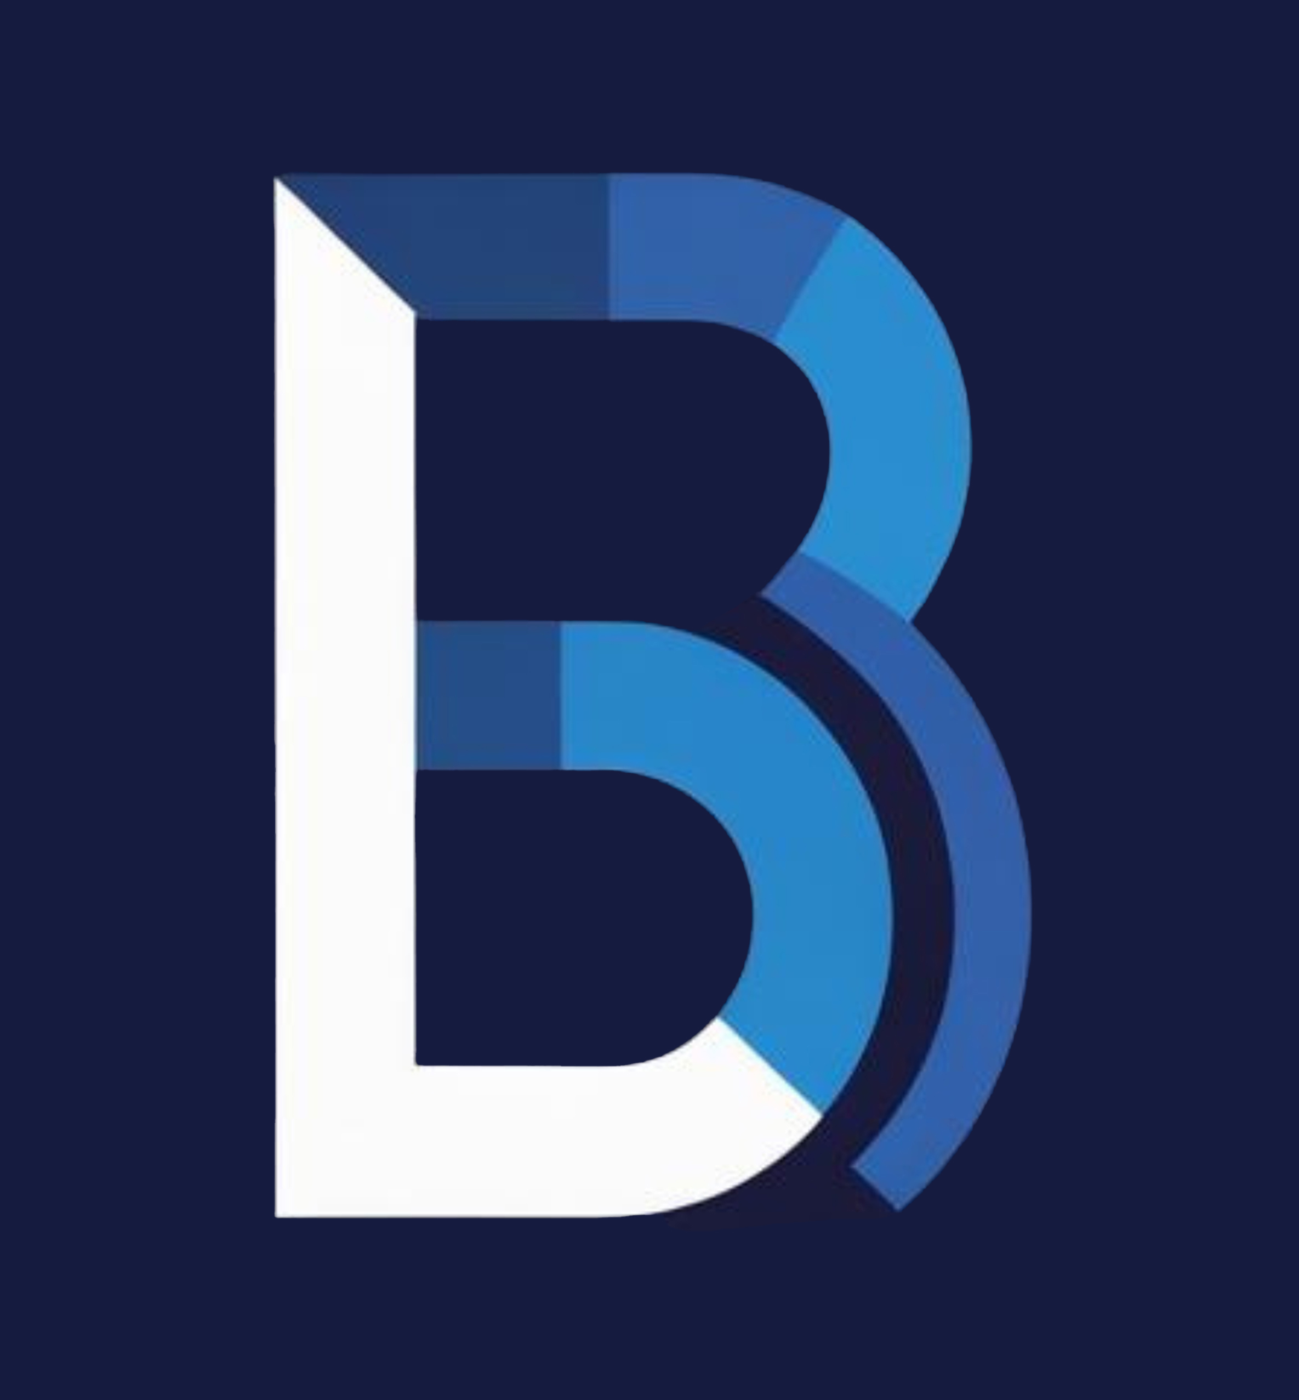

BLAU BATCH
Visual Identity Guide

Full-Spectrum Masterbatch Solutions
v1.2 | 2026

www.blaubatch.com
Confidential — For authorised use only

TABLE OF CONTENTS

01 Introduction & Purpose
02 The Logo System
03 Text-Only Logo
04 Arabic Brand Name
05 Logo Clear Space & Minimum Sizes
06 Brand Name: How We Write It
07 Logo on Backgrounds
08 Monochrome & Silhouette Versions
09 Incorrect Logo Usage
10 Colour Palette
11 Colour Usage Rules
12 Typography System
13 Typography Hierarchy & Scale
14 Stationery & Applications
15 Digital Applications
16 Iconography & Graphic Elements
17 Patterns & Textures
18 Motion & Animation
19 Co-Branding & Partner Logos
20 Brand Approval & Contact
01 INTRODUCTION & PURPOSE
This Visual Identity Guide is the definitive reference for how Blau Batch presents itself visually across every medium, channel, and touchpoint. It governs the use of our logo, colours, typography, and brand assets — ensuring consistency whether the brand appears on a business card, a factory signboard, a digital advertisement, or a technical data sheet.
Visual consistency is not a creative limitation. It is a competitive advantage. In B2B industrial markets, a disciplined brand identity signals reliability, professionalism, and attention to detail — the same qualities our customers expect from our products and service.
Who This Guide Is For
• Internal marketing and communications teams
• External design agencies and print vendors
• Sales teams preparing proposals and presentations
• Digital teams managing web, social, and email assets
• Partner organisations using the Blau Batch brand in co-branded materials
Core Principle
Every application of the Blau Batch brand must be recognisable, consistent, and professional. When in doubt, refer to this guide. When this guide does not cover a specific case, contact the Marketing & Operations Manager for approval before proceeding.

02 THE LOGO SYSTEM
The Blau Batch logo is built around a distinctive geometric ‘B’ lettermark composed of layered blue tones that convey precision, depth, and industrial confidence. The logo system is supplied as one logo pack (Brand Assets/Logos/BlauBatch_Logo_Pack) with versions designed for specific contexts; the main ones are shown below.
2.1 Primary Logo (Full Lockup)
The primary logo consists of the ‘B’ lettermark on its official navy square background. This is the default logo for all branded communications including brochures, trade show displays, proposals, product catalogues, and formal print materials.
Primary Logo — B lettermark on navy background
Always use this version when space permits and the logo will be displayed at a prominent size.
2.2 Horizontal Logo (Wordmark Lockup)
The horizontal logo combines the ‘B’ lettermark with the company name ‘BLAU BATCH’ set in Inter Black (900, −0.02em tracking), arranged in a single horizontal lockup. The tagline is not part of the lockup; when needed, set it separately in Inter. Use for letterheads, email signatures, website navigation, presentation title slides, and trade show banners.
  03_Horizontal — LightBG |   03_Horizontal — DarkBG
2.3 Logomark Only (Standalone B)
The standalone ‘B’ lettermark without any text. Use only when brand context is established or space is extremely limited: favicons, app icons, social media avatars, watermarks, embossed packaging, and small promotional items.
On Navy Background | On Light Background
2.4 Logo File Formats
SVG | Preferred. Web, apps, print and anything that scales — fully outlined vector, no font needed
PNG | PowerPoint, Word, email, social media — transparent background
JPG | Master reference only (01_Primary)

ℹ ASSET NOTE: All official logo files are in Brand Assets/Logos/BlauBatch_Logo_Pack: 01 Primary, 02 Logomark, 03 Horizontal, 04 Arabic, 05 Wordmark, 06 Mono, 07 Favicon & App Icon, 08 Boxed, 09 Coraplast, 10 Co-brand. Always use these files — never recreate, trace, retype or screenshot the logo.

03 TEXT-ONLY LOGO
The text-only logo is the brand name ‘BLAU BATCH’ set in Inter Black (900), all caps, at −0.02em tracking, supplied as 05_Wordmark files. It is an approved logo variant for contexts where the B lettermark is not suitable or when a typographic-only treatment is preferred.
3.1 Text-Only Logo — Navy on Light Backgrounds
Use the Deep Navy (#141B3E) text-only logo on white, off-white, and light grey backgrounds.
  White (#FFFFFF) | Off-White (#F5F5F5) | Light Grey (#DCDCDC)
3.2 Text-Only Logo — White on Dark Backgrounds
Use the White (#FFFFFF) text-only logo on Deep Navy, Steel Blue, Black, or any dark background.
  Deep Navy (#141B3E) | Steel Blue (#23447A) | Black (#000000)
3.3 Text-Only Logo with Tagline
The text-only logo may optionally include the tagline ‘Full-Spectrum Masterbatch Solutions’ set below it in Inter Regular. The tagline is set as text; it is not part of the wordmark files. This version is used for presentations, proposals, and document covers.
Full-Spectrum Masterbatch Solutions  Navy on White | Full-Spectrum Masterbatch Solutions  White on Navy
3.4 Text-Only Logo Rules
• Always place the supplied 05_Wordmark file (Inter Black 900, all caps, −0.02em tracking)
• Never retype the wordmark, even in Inter; the files are drawn and optically spaced
• Never use a different typeface, weight, or case for the text-only logo
• The text-only logo follows the same clear space rules as the primary logo
• Never combine the text-only logo and the B lettermark in an unofficial arrangement

04 ARABIC BRAND NAME
For Arabic-language markets and materials, the brand name has an approved Arabic rendering. This is used in bilingual communications, MENA-market sales materials, and Arabic social media content.
4.1 Approved Arabic Brand Name
بــلاو بــاتش
Cairo Black · Approved Arabic rendering of BLAU BATCH (04_Arabic logo files)
4.2 Arabic on Light Backgrounds
Use the Deep Navy (#141B3E) Arabic brand name on white, off-white, and light grey backgrounds.
بــلاو بــاتش  White | بــلاو بــاتش  Off-White | بــلاو بــاتش  Light Grey
4.3 Arabic on Dark Backgrounds
Use the White (#FFFFFF) Arabic brand name on Deep Navy, Steel Blue, or Black backgrounds.
بــلاو بــاتش  Deep Navy | بــلاو بــاتش  Steel Blue | بــلاو بــاتش  Black
4.4 Bilingual Lockup
In bilingual applications, the Latin and Arabic brand names appear together. The Latin name always appears first (left or top), with the Arabic name second (right or below).
BLAU BATCH  بــلاو بــاتش  Bilingual — Light | BLAU BATCH  بــلاو بــاتش  Bilingual — Dark
4.5 Arabic Brand Name Rules
• For the logo, use the 04_Arabic lockup files (Cairo Black). In running Arabic text, set the name in Cairo Bold
• Noto Sans Arabic Bold is an approved alternative
• Always use the exact approved rendering: بــلاو بــاتش
• Never alter, respace, or re-typeset the Arabic name independently
• In bilingual layouts, maintain visual balance between Latin and Arabic names
• Arabic text always uses right-to-left (RTL) layout — never mix LTR and RTL in the same design element
• All Arabic brand materials require approval from the Marketing & Operations Manager before publication

05 LOGO CLEAR SPACE & MINIMUM SIZES
5.1 Clear Space (Exclusion Zone)
The clear space is the minimum protected area surrounding the logo where no other visual element may appear. It is defined as the height of the ‘B’ letterform (X), applied equally on all four sides.
↓ X (clear space)

X ← → X

↑ X (clear space)

X = Height of the B letterform. No elements may enter the exclusion zone.
5.1b Clear Space — Absolute Measurements
At minimum logo size, X resolves to the following fixed values. Use these when communicating with print vendors or developers who need exact specifications.
CONTEXT | MIN CLEAR SPACE (X) | PREFERRED CLEAR SPACE
Print (brochures, TDS) | 5 mm | 10 mm
Large format (signage) | 20 mm | 40 mm
Business card | 3 mm | 5 mm
Digital (web, email) | 20 px | 40 px
Social media avatar | 8 px | 16 px
Favicon / App icon | 2 px | 4 px

5.2 Minimum Sizes
APPLICATION | MINIMUM SIZE | LOGO VERSION
Print (brochures, datasheets) | 25 mm width | Primary or Horizontal
Digital (web, email, social) | 120 px width | Primary or Horizontal
Favicon / App Icon | 32 × 32 px | Logomark Only
Business Card | 15 mm width | Logomark or Horizontal
Large Format (signage) | 100 mm width | Primary

06 BRAND NAME: HOW WE WRITE IT
The brand name is a critical part of our visual identity. Incorrect spelling, capitalisation, or formatting undermines brand recognition. Follow these rules without exception.
6.1 Official Name
BLAU BATCH
Two words. Always capitalised. No hyphen, no camelCase, no abbreviation.
6.2 Acceptable Written Forms
✓ CORRECT  BLAU BATCH  All logo and display uses — always caps  Blau Batch  In running body text only, title case  blaubatch.com  Domain/URL only, lowercase, no space  بــلاو بــاتش  Approved Arabic rendering only | ✗ INCORRECT  BlauBatch  No camelCase  blau batch  Never all lowercase in text  Blau-Batch / BB / B.B.  No hyphens, abbreviations, or initials  Unofficial Arabic transliterations  Only the approved Arabic form is permitted
6.3 Tagline
Full-Spectrum Masterbatch Solutions
The tagline is always written in title case. It may appear beneath the logo in formal applications.

07 LOGO ON BACKGROUNDS
The logo must maintain high contrast and visual clarity across all background applications.
7.0 Transparency Guidance
PRIMARY LOGO (JPG)
Includes the navy background container as part of the image. Use this version on white, light, or photographic backgrounds where the navy square provides brand consistency and clear framing.

LOGOMARK (PNG — TRANSPARENT)
The B lettermark without background. Use on dark or navy backgrounds where the container square is unnecessary, or when the logo must float over a coloured surface. Available as a transparent PNG or SVG.

RULE OF THUMB: If the background is light → use the Primary (with navy container). If the background is dark navy or black → use the transparent Logomark.

7.1 On White / Light Backgrounds
White | Off-White | Light Grey
7.2 On Dark / Navy Backgrounds
Deep Navy | Steel Blue | Black

⚠ NOTE ON BLACK BACKGROUND: Use of the logo on a pure black (#000000) background is not a standard brand application and is unlikely to arise in normal communications. The logo’s built-in navy container does not provide optimal contrast against black. If a black background is required (e.g., specific exhibition or event context), this must be reviewed and approved by the Marketing & Operations Manager before use.

7.3 On Coloured & Photographic Backgrounds
On non-brand colours, always place the logo inside a solid navy or white container block. On photographic backgrounds, apply a semi-transparent navy overlay (min 80% opacity) behind the logo.

08 MONOCHROME & SILHOUETTE VERSIONS
For single-colour print, embossing, engraving, fax, or merchandise, use approved monochrome versions of the logo. In monochrome applications, the multi-tonal B lettermark is reduced to a single flat colour, preserving the outer silhouette shape only.
8.1 Monochrome Versions
Two approved single-colour versions. Each flattens the layered B lettermark into one solid colour inside its square.
NAVY ON LIGHT | WHITE ON DARK
  Flat Navy #141B3E  Single-ink print, embossing, engraving |   Flat White #FFFFFF  Foil stamp, dark merchandise

Black, Steel Blue and white-on-black single-colour versions are retired (November 2026). For greyscale-only reproduction, use Mono Navy; it prints as 90% black (see 8.4).

8.2 Monochrome Asset Index
FILE (06_Mono) | USE CASE
BlauBatch_Mono_Navy.svg / .png | Single-ink print, letterheads, datasheets, embossing on light stock
BlauBatch_Mono_White.svg / .png | Foil stamp, screen print and merchandise on dark surfaces
8.3 Greyscale Mapping
• Deep Navy Deep Navy → 90% Black
• Steel Blue Steel Blue → 65% Black
• Sky Blue Sky Blue → 45% Black
• Manufacturing Amber Manufacturing Amber → 55% Black
8.4 Silhouette / Embossed Mark
For embossing, debossing, engraving, or watermark: use the simplified silhouette B lettermark only (no wordmark), reduced to a single flat shape.

09 INCORRECT LOGO USAGE
The following are strictly prohibited:
✗ Do not stretch or compress  Maintain original aspect ratio at all times. | ✗ Do not rotate or tilt  Always upright and level, never angled.
✗ Do not add effects  No shadows, glows, bevels, outlines, gradients. | ✗ Do not recolour  Only approved colour versions permitted.
✗ Do not place on busy images  Use a solid backing panel for legibility. | ✗ Do not alter proportions  Lettermark and wordmark spacing as supplied.
✗ Do not use low-res rasters  Always use vector for print. Never screenshot. | ✗ Do not crop or mask  Full logo must be visible at all times.

Visual Example — What NOT to Do:
✗ Stretched / distorted | ✗ Compressed / squished

10 COLOUR PALETTE
10.1 Primary Brand Colours
Deep Navy
HEX: #141B3E
RGB: 20, 27, 62
CMYK: 68, 56, 0, 76
Pantone: 2767 C
Steel Blue
HEX: #23447A
RGB: 35, 68, 122
CMYK: 71, 44, 0, 52
Pantone: 295 C
Sky Blue
HEX: #2B8DD0
RGB: 43, 141, 208
CMYK: 79, 32, 0, 18
Pantone: 285 C
10.2 Accent & Neutral Colours
Manufacturing Amber
HEX: #D4840A
RGB: 212, 132, 10
CMYK: 0, 38, 95, 17
Pantone: 144 C
Light Grey
HEX: #DCDCDC
RGB: 220, 220, 220
CMYK: 0, 0, 0, 14
Pantone: Cool Gray 1 C
White
HEX: #FFFFFF
RGB: 255, 255, 255
CMYK: 0, 0, 0, 0
Pantone: 11-0601 TPX

11 COLOUR USAGE RULES
Deep Navy | Primary background, dark panels, main headings, logo base, cover pages
Steel Blue | Secondary headings, navigation, supporting panels, table headers
Sky Blue | Accents, CTA buttons, hyperlinks, highlights, icons, product badges
Manufacturing Amber | Manufacturing accent ONLY: ‘MANUFACTURED’ labels. Never dominant.
Light Grey | Page backgrounds, alternate table rows, subtle dividers
White | Text on dark backgrounds, clean print backgrounds, whitespace
11.1 Colour Ratio
• 60% — Deep Navy + White (dominant foundation)
• 25% — Steel Blue + Sky Blue (supporting structure and accents)
• 10% — Light Grey (neutral spacing and dividers)
• 5% — Manufacturing Amber (sparingly, manufacturing-specific only)

11.2 WCAG Accessibility Contrast
All text and logo applications must meet WCAG 2.1 minimum contrast standards. AA (4.5:1) is required for all body text; AAA (7:1) is the target for headings and logo applications.
COMBINATION | CONTRAST RATIO | WCAG AA | WCAG AAA | NOTES
Navy on White | #141B3E / #FFF | 14.7:1 | ✅ Pass | ✅ Pass
White on Navy | #FFF / #141B3E | 14.7:1 | ✅ Pass | ✅ Pass
Steel Blue on White | #23447A / #FFF | 7.2:1 | ✅ Pass | ✅ Pass
Sky Blue on White | #2B8DD0 / #FFF | 4.6:1 | ✅ Pass | ❌ Fail
Sky Blue on Navy | #2B8DD0 / #141B3E | 3.2:1 | ❌ Fail | ❌ Fail
Amber on White | #D4840A / #FFF | 3.2:1 | ❌ Fail | ❌ Fail
White on Steel Blue | #FFF / #23447A | 7.2:1 | ✅ Pass | ✅ Pass
Dark Grey on White | #333333 / #FFF | 12.6:1 | ✅ Pass | ✅ Pass

⚠ AMBER TEXT RULE: Manufacturing Amber (#D4840A) has a contrast ratio of only 3.2:1 on white — below WCAG 2.1 AA. It must NEVER be used for body text or any text below 18pt / Bold. Permitted uses: graphic accents, badge labels (e.g. ‘MANUFACTURED’ chips), decorative callouts at large size only.

11.3 Design Tokens — Spacing, Radius & Layout
The following tokens define the structural system. Apply consistently across all digital and print applications to ensure visual coherence.
TOKEN | VALUE | USAGE
border-radius-none | 0px / 0mm | Print documents, business cards, TDS headers — sharp industrial aesthetic
border-radius-sm | 2px | Icon bounding boxes, small UI tags, badge chips
border-radius-md | 4px | UI cards, form inputs, modal containers, CTA buttons
border-radius-lg | 8px | Notification panels, feature callout blocks
grid-columns-print | 12 columns | Print layouts: 10mm margins, 5mm gutters, A4/Letter
grid-columns-web | 12 columns | Web: 80px margins (desktop), 24px (mobile), 24px gutters
grid-margin-print | 10mm | Minimum page margin for all print documents
grid-margin-web | 80px / 24px | Desktop / mobile page margin
grid-gutter-print | 5mm | Column gutter for multi-column print layouts
grid-gutter-web | 24px | Column gutter for web layouts
space-xs | 4px / 1mm | Icon-to-label gaps, tight inline spacing
space-sm | 8px / 2mm | Component internal padding (compact)
space-md | 16px / 4mm | Standard component padding, list item spacing
space-lg | 32px / 8mm | Section spacing, card padding
space-xl | 64px / 16mm | Page section breaks, hero padding
space-xxl | 128px / 30mm | Cover page spacing, large banner margins
shadow-none | none | Flat print, flat UI panels (default brand style)
shadow-low | 0 1px 3px rgba(20,27,62,0.12) | Cards, dropdowns, tooltips
shadow-mid | 0 4px 12px rgba(20,27,62,0.18) | Modals, floating panels, popovers

12 TYPOGRAPHY SYSTEM
12.1 Brand Typeface — Inter
Role | All Latin text: display titles, headings, body copy, captions, data tables, UI, TDS, presentations
Weights | Black (900) · ExtraBold (800) · Bold (700) · SemiBold (600) · Medium (500) · Regular (400)
Style | All Caps preferred for brand headlines; Title Case for subheadings; Sentence case for body. Tabular figures for spec data
Source | Google Fonts / rsms.me/inter (free, SIL OFL) — files in Brand Assets/Fonts
Fallback | Arial → Helvetica → Sans-serif
12.2 Logo Wordmark — Inter Black (logo files)
Role | The BLAU BATCH wordmark in every official logo file (03 Horizontal, 05 Wordmark, 08 Boxed, 10 Co-brand)
Weights | Inter Black (900), all caps, −0.02em tracking
Rule | Always place the supplied logo file. Never retype the logo; the files are drawn and optically spaced
Source | Brand Assets/Logos/BlauBatch_Logo_Pack. Montserrat is retired
Line height | Inter: 1.5× body, 1.2× headings
12.3 Arabic Typeface — Cairo
Role | Arabic brand name, Arabic body copy, bilingual materials
Weights | Bold (700) for brand name · Regular (400) for body
Alternative | Noto Sans Arabic (Google Fonts)
Source | Google Fonts (free) — fonts.google.com/specimen/Cairo
Direction | Always RTL — never mix LTR and RTL in same element

13 TYPOGRAPHY HIERARCHY & SCALE
FULL-SPECTRUM MASTERBATCH SOLUTIONS
Display / Cover Title — Inter Black · 48–72pt · All Caps

SECTION HEADING — HEADING 1
Inter ExtraBold · 36–48pt · All Caps

Subsection Heading — Heading 2
Inter Bold · 28–32pt · Title Case

Sub-Subsection Heading — Heading 3
Inter SemiBold · 20–24pt · Title Case

Body copy set in Inter Regular at 11–12pt with 1.5× line height for readability.
Inter Regular · 10–12pt · Sentence Case

CAPTION AND LABEL TEXT — METADATA AND ANNOTATIONS
Inter Medium · 8–9pt · All Caps or Sentence Case

14 STATIONERY & APPLICATIONS
14.1 Business Card
Dimensions | 90 × 55 mm (standard international)
Front — Name | Inter Bold 10pt, charcoal
Front — Title | Inter Regular 8pt, Steel Blue (#23447A)
Front — Contact | Inter Regular 7.5pt — phone, email, website
Back | Full B lettermark centred on navy background
Print Spec | CMYK · 350gsm coated · Matt laminate + UV spot on logo

Adham Zahran  Marketing & Operations Manager  +2 0102 2227723  adham.zahran@blaubatch.com  www.blaubatch.com  FRONT | BACK
14.2 Letterhead
• Header: BLAU BATCH horizontal lockup + www.blaubatch.com — top left
• Body: Inter 11pt, single spacing, 1.15 line height
• Footer: Office address · Phone · Email · Website in Inter 8pt
• Paper: A4 white 100gsm for print; digital PDF on white
• Colour accents: Navy and Sky Blue only — no amber on letterhead
14.3 Email Signature
ℹ PLATFORM CONSTRAINT — ARIAL ONLY: Email clients (Outlook, Gmail, Apple Mail) do not load web fonts. Arial is specified here as a platform constraint, not as a brand preference. The brand typeface — Inter — remains the standard for all other touchpoints. The logo image embedded as a PNG ensures brand consistency regardless of font rendering.

Name | Arial Bold 11pt, charcoal — (platform constraint: see note above)
Title | Arial 10pt, Steel Blue (#23447A)
Phone | Arial 9pt, charcoal
Email | Arial 9pt, Sky Blue, no underline
Website | Arial 9pt, Sky Blue, no underline
Logo | Horizontal lockup — 180px wide — PNG transparent
Disclaimer | Arial 7.5pt, grey, thin grey rule above

15 DIGITAL APPLICATIONS
15.1 Website
• Clean, minimal layouts — product information first
• Mobile-responsive across all breakpoints
• Navy backgrounds, Sky Blue CTAs, Amber for manufacturing highlights only
• Inter loaded from Google Fonts; Arial/Helvetica as web-safe fallbacks
15.2 Social Media Profiles
Profile Image | Logomark (B) on navy — consistent across all platforms
Cover / Banner | Navy background with horizontal lockup and tagline
Handle | @BlauBatch — consistent across all platforms
Post Visuals | White or navy backgrounds, brand palette, no stock photography

LinkedIn | Instagram | Facebook
15.3 Photography Rules
• Clean, well-lit, sharply in focus — no blurred or poorly lit imagery
• Colour accuracy critical — masterbatch colours must render faithfully
• No stock photography. No AI-generated imagery. No heavy filters.
• 300 dpi for print; 72 dpi web-optimised for digital

16 ICONOGRAPHY & GRAPHIC ELEMENTS
Icons and graphic elements used across BLAU BATCH communications must follow a consistent visual language that aligns with the brand’s precision-focused identity.
16.1 Icon Style
Style | Line icons (outlined), geometric, clean corners
Stroke Weight | 2px at 24×24px base size — scale proportionally
Corner Radius | 2px rounded corners for consistency
Colour | Deep Navy (#141B3E) primary · Sky Blue (#2B8DD0) for interactive/hover states · White on dark backgrounds
Sizing Grid | 24×24px base unit · Scale in multiples: 16, 24, 32, 48, 64px
Optical Padding | 2px internal padding within the bounding box
16.2 Approved Icon Library
The approved icon library for Blau Batch is Phosphor Icons — a clean, consistent line-icon set that matches the brand’s geometric and precision-focused aesthetic. Always use the regular (outlined) weight.
Library | Phosphor Icons — phosphoricons.com
Weight to use | Regular (outlined) only — never Thin or Bold weight in brand contexts
Web | npm: phosphor-react / phosphor-vue / phosphor-svelte · or CDN SVG sprites
Print | Export individual SVGs from phosphoricons.com at required size
Figma | Phosphor Icons Figma plugin (search ‘Phosphor’ in Figma Community)
Licence | MIT — free for commercial use, no attribution required

16.3 Icon Usage Rules
• Always source icons from Phosphor Icons (regular weight) — never mix icon libraries or styles
• Maintain consistent stroke weight across all icons in a single layout
• Icons must sit within the brand colour palette — never use colours outside the system
• Use Sky Blue icons for interactive/clickable elements; Deep Navy for static/informational
• Minimum icon size: 16×16px on screen, 4mm×4mm in print
• Never combine filled and outlined icons in the same context
• For contexts where Phosphor is unavailable, use Material Symbols (outlined) as the only permitted alternative
16.3 Graphic Elements
Supporting graphic elements are derived from the geometric language of the B lettermark:
• Angular Dividers: Diagonal divider lines at the same angle as the lettermark’s facets (approx. 30°)
• Layered Panels: Layered translucent rectangles in brand blues, used as section backgrounds or accent blocks
• Accent Lines: Thin Sky Blue lines (1–2px) for separating content sections, table dividers, and pull-quote borders
• Background Geometry: Subtle geometric patterns at 5–10% opacity for large background areas

17 PATTERNS & TEXTURES
Branded patterns extend the visual identity into backgrounds, packaging, and environmental design. Two approved pattern types are defined below. Both use official logo assets — never recreate pattern elements manually.
★ PREFERRED PATTERN: The Text-Only pattern (Section 17.2) is the recommended choice for all background pattern applications. It reads clearly at any scale, tiles cleanly, and never creates visual confusion with the primary B lettermark logo.

17.1 Logomark Pattern — Cutout B Grid
A repeating grid of the transparent B lettermark cutout at reduced opacity. For use in large-format print backgrounds, packaging liners, trade show panels, and environmental graphics. Reduce to 8–12% opacity in production so it never competes with foreground content.
On white — reduce to 8% opacity in production | On navy — reduce to 10% lighter than base in production
  

Note: The cutout B lettermark pattern works best at large scale (signage, packaging, booth panels). At small scale or high density, use the Text-Only pattern instead.

★ PREFERRED PATTERN USE ★
17.2 Text-Only Pattern — BLAU BATCH Wordmark Grid
A repeating grid of the BLAU BATCH wordmark (05_Wordmark files, Inter Black). This is the preferred pattern for most applications: it tiles cleanly at any scale, is immediately legible as a brand watermark, and never creates confusion with the primary logo. Use on document backgrounds, presentation slides, social media templates, and promotional materials.
Navy on white — reduce to 8% opacity in production | White on navy — reduce to 10% opacity in production
17.3 Secondary Pattern — Angular Stripes
Diagonal stripe pattern using brand blues at varying opacities (10–20%). Used on packaging wraps, trade show booth panels, and promotional banners. Stripes follow the 30° angle derived from the lettermark geometry.
17.4 Pattern Rules
• ★ Text-Only wordmark pattern is the preferred choice for most backgrounds and templates
• Logomark (cutout B) pattern is reserved for large-format and environmental applications
• Patterns must never compete with the logo — always below 15% opacity when behind content
• Only brand palette colours permitted (Deep Navy, Steel Blue, Sky Blue)
• Manufacturing Amber is never used in patterns
• Patterns must tile seamlessly at any scale
• Never stretch, skew, or rotate the pattern grid independently
• Pattern source files are available from the Marketing & Operations Manager

18 MOTION & ANIMATION
Motion design for BLAU BATCH is purposeful, restrained, and premium. Animations reinforce the brand’s precision engineering identity — smooth, confident, and never flashy.
18.1 Logo Animation
Reveal Style | The B lettermark builds layer by layer — each blue tone fades in sequentially from back to front, suggesting depth and precision
Duration | 1.2–1.8 seconds total (0.3s per layer)
Easing | ease-out (cubic-bezier 0.25, 0.46, 0.45, 0.94) — smooth deceleration
End State | Hold full logo for minimum 2 seconds before any transition
Sound | Optional: a subtle, low metallic tone — no swooshes, no jingles
18.2 UI & Web Transitions
• Page transitions: fade-in (300ms ease-out) — no sliding, no bouncing
• Button hover: background colour shift over 200ms (e.g., Sky Blue → Steel Blue)
• Card/panel reveals: fade-up (translate Y 20px → 0, opacity 0 → 1, 400ms ease-out)
• Loading states: subtle pulse animation using Sky Blue at reduced opacity
• Never use: spinning logos, bouncing elements, confetti, parallax effects, or aggressive zoom transitions
18.3 Video & Presentation
• Opening bumper: logo animation (as above) on navy background, 3 seconds total
• Lower thirds: navy bar with white Inter text, Sky Blue accent line, fade-in 400ms
• End card: full logo lockup centred on navy, tagline below, hold for 4 seconds minimum
• Transitions between sections: simple crossfade (500ms) — no wipes, no star transitions
• Title cards: Inter Bold white text on navy, fade-in with 200ms stagger per line
18.4 Motion Principles
Purposeful | Every animation must serve a functional purpose — guide attention, indicate state change, or provide feedback. No decorative motion.
Restrained | Subtle and smooth. Maximum 500ms for any single transition. No overshooting, bouncing, or elastic effects.
Consistent | Use the same easing curve (ease-out) and timing scale across all touchpoints. Motion should feel unified.

19 CO-BRANDING & PARTNER LOGOS
• BLAU BATCH logo must be at least equal in visual weight to partner logo
• Minimum 2× standard clear space between logos
• A thin divider line (Light Grey #DCDCDC) may separate logos
• Never blend, merge, or combine logos into a single mark
• All co-branded materials require Marketing & Operations Manager approval
16.1 Coraplast Co-Branding
BLAU BATCH logo appears first (left or top), Coraplast logo second, separated by a divider.
BLAU BATCH |  | 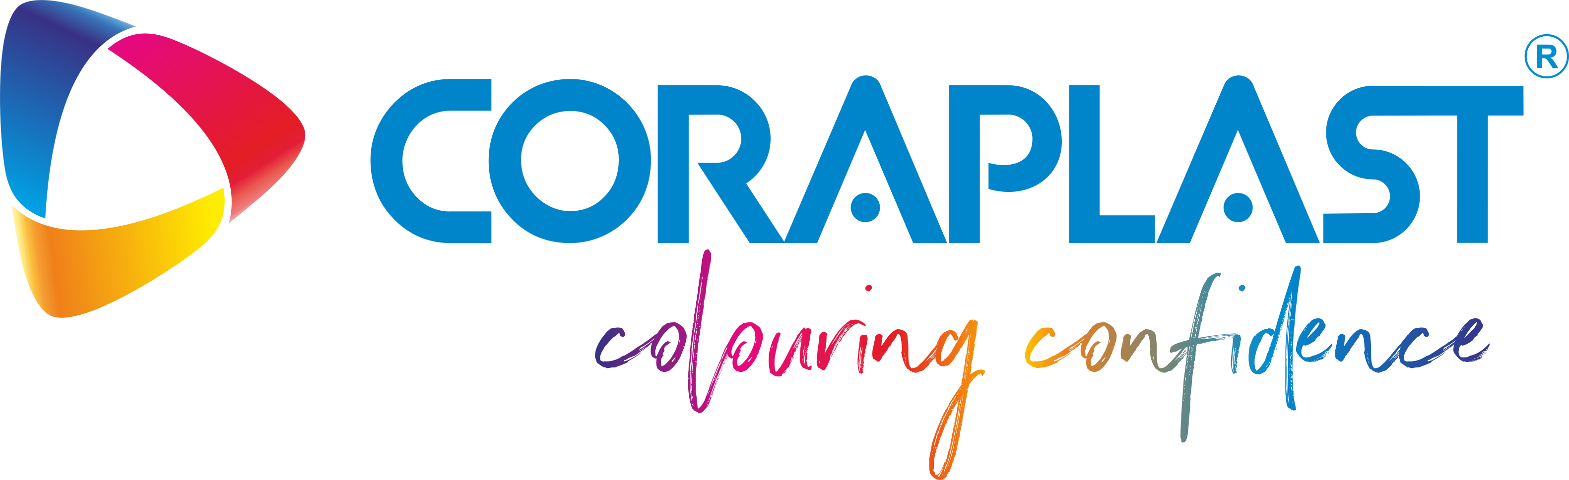  Authorised Distribution Partner

20 BRAND APPROVAL & CONTACT
All uses of the BLAU BATCH logo, brand colours, and brand assets must be reviewed and approved by the Marketing & Operations Manager before publication or distribution.

BRAND APPROVAL CONTACT
Adham Zahran
Marketing & Operations Manager

Email: adham.zahran@blaubatch.com
Company: info@blaubatch.com
Phone: +2 0102 2227723
Website: www.blaubatch.com

BLAU BATCH
بــلاو بــاتش
Full-Spectrum Masterbatch Solutions
Manufacturer · Distributor · Partner

